Bradley Davis

This document explains the components of CougSat-1 from a high level, their integration, and their operation

CougSat-1

Cougs in Space’s First Satellite

Revision: 1.3.2



Table of Contents

1 Introduction 2

1.1 Background 2

1.2 Environmental Conditions 3

2 Mission Objective 4

3 Design Criteria 5

4 Design Considerations 6

5 Spacecraft Design 7

5.1 Satellite Bus 8

5.1.1 C&DH – Command and Data Handling 8

5.1.2 EPS – Electrical Power System 8

5.1.3 ADCS – Attitude Determination and Control System 8

5.1.4 Comms – Communication System 9

5.1.5 IFJR – In-Flight JTAG Reprogrammer 9

5.1.6 Mechanical Structure 9

5.2 Payload 9

5.2.1 Validating the Satellite Bus 9

5.2.2 Germination Experiment 9

5.2.3 Earth Imaging 10

6 Concept of Operations 11

6.1 Before Deployment 11

6.2 Immediately Following Deployment 11

6.3 First Few Days 11

6.4 Germination Experiment 12

6.5 Normal Operations 12

6.5.1 Mode 1: Safe 13

6.5.2 Mode 2: System Maintenance & Standby 13

6.5.3 Mode 3: Science 13

6.5.4 Mode 4: Transmit 13

6.6 Decommissioning 14

# 1 Introduction

CougSat-1 is a 1U (single CubeSat unit) nanosatellite created by Washington State University’s (WSU) Cougs in Space club (CIS). The aim of this document is to describe CougSat-1 entirely from objective to top level design. Upon launch, CougSat-1 will become WSU’s first satellite and pave the way for many more to come.

## 1.1 Background

A CubeSat is a nanosatellite (wet mass: $1 to 10 kg$) that is comprised of units, each a $100 mm$ cube, see figure 1. Cal Poly and Stanford developed the CubeSat specifications. In brief, a single unit is a $100 mm$ cube with a mass of up to $1.33 kg$. A CubeSat can span multiple units: 1U, 2U, 3U, 6U, and 12U. Cal Poly also created the CubeSat deployment system, called the Poly Picosatellite Orbital Deployer (P-POD). The P-POD uses a spring mechanism to push the CubeSats out into orbit from the launch provider’s vehicle. Visit the CubeSat website at [cubesat.org](http://cubesat.org) for more information.

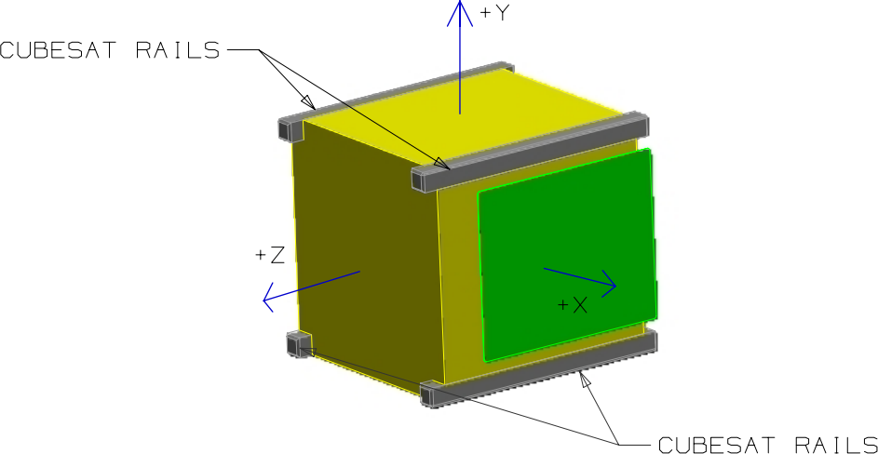

Figure 1: 1U CubeSat. Credit: Cal Poly CubeSat Program

## 1.2 Environmental Conditions

CubeSats reside in low earth orbit at an altitude between $200 and 900 km$. Throughout designing, CougSat-1 assumes an orbital altitude of $400 km$, unless otherwise specified. At this altitude, the orbital period is about $90 minutes$ and the mission lifespan is about a year. The mission lifespan depends on actual orbital properties and one year is a reasonable minimum for lifespan driven design choices. Not until ejection from the launch provider will CougSat-1’s orbit be known for certain.

At $400 km$, CougSat-1 will be orbiting with a speed of $7.6 kms^{-1}$. Although atmospheric drag is the primary cause of orbital decay, it can usually be assumed to be negligible. Thus, CougSat-1 will be essentially in free-space. During its orbit of about $90 minutes$, roughly $30 minutes$ are spent eclipsed behind the earth. This duration varies on the beta angle of the orbit, worst case scenario yields a minimum solar duration of [1]. The sun irradiates a substantial amount of energy which heats up CougSat-1. When eclipsed, this heat irradiates away, and the temperature begins to drop. The temperature can fluctuate between $-100 and 120°C$ every orbit[2]. The magnetic field strength is similar to that on Earth’s surface: [3].

# 2 Mission Objective

The mission objective of CougSat-1 is as follow in order of priority:

1. Develop a reliable and robust bus for nanosatellites
2. Be capable of reprogramming the satellite
3. Put a WSU cougar head into orbit
4. Test an experiment apparatus studying plant germination in microgravity

As CougSat-1 is the first satellite created at WSU, the primary objective is to **develop a reliable and robust bus for nanosatellites**. The bus consists of all the subsystems on the satellite expect those relating to the payload. These include: ADCS, C&DH, Comms, EPS, and the mechanical structure. A reliable and robust design of these components will improve the development of future CubeSats as only the payload specific subsystems will need to be designed and tested.

As we might want to improve the software running on the satellite after launch, the secondary objective is to **be capable of reprogramming** the satellite’s processors. The subsystem that will perform the reprogramming is the IFJR. Ideally all programmable processors will be capable of being reprogrammed in orbit, but design constraints may limit some processors from being reprogrammed.

The tertiary objective is to share the WSU pride with as many people as possible. CougSat-1 will **put a WSU cougar head into orbit**. This could be a sticker, PCB feature, engraving, or a mechanical part. Furthermore, every photo CougSat-1 takes of Earth will have a WSU cougar head in the corner. Ideally this is a real piece of the satellite, but an image overlay would be acceptable.

The last objective comes from the Astrobiology department at WSU. They requested CougSat-1 to **test an experimental apparatus** that will study plant germination in microgravity. As humans are preparing for long distance space travel, sustainable food supplies need to be researched to ensure the travelers survive their trip. A future CougSat may have a full experiment researching agriculture in microgravity.

# 3 Design Criteria

CougSat-1 must possess the following features:

* Highly reliable primary communication system for commands and telemetry
* EPS capable of sustaining CougSat-1 during the entire mission duration
* Mechanical structure to support and protect the components
* ADCS to orient CougSat-1 at points of interest or the sun for charging
* Plant germination experiment apparatus
* Radio beacon to identify and track CougSat-1 during communication passes, normally transmitting telemetry
* Visible spectrum camera to image Earth

In addition, CougSat-1 should possess the following additional features:

* High speed secondary communication system for payload data transfer
* Deployable solar panels for less time charging and more time performing payload operations
* Visible light beacon for anyone to see CougSat-1 at night

# 4 Design Considerations

The primary design considerations for CougSat-1 come from the specifications created by [CubeSat](http://www.cubesat.org/resources/) and the environmental conditions experienced in low Earth orbit. These considerations ensure that CougSat-1 will successfully be placed in LEO and survive for at least one year, the mission duration.

The secondary design considerations come from the mission objective and design criteria. Every component on CougSat-1 should contribute towards achieving these goals. These considerations ensure that CougSat-1 will successfully complete its mission.

Any tertiary design considerations are unique to each subsystem and are explained in their documentation.

# 5 Spacecraft Design

This section describes CougSat-1 from a high-level perspective. The various subsystems all interact over the shared backplane. A functional block diagram of CougSat-1 is presented in figure 2 and a preliminary 3D rendering is shown in figure 3.

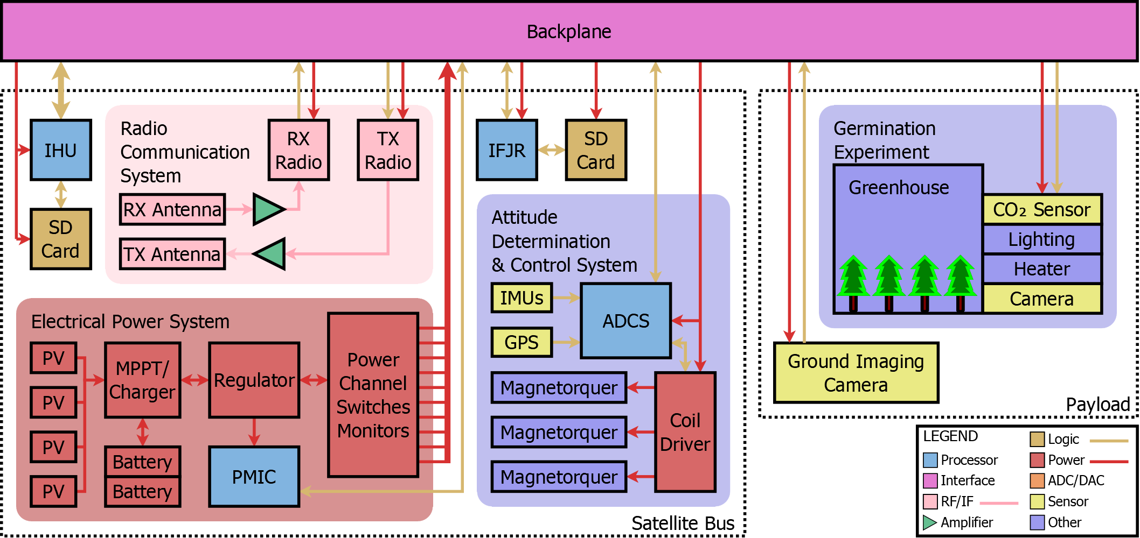

Figure 2: CougSat-1 Functional Block Diagram

Germination Experiment

EPS

Avionics (C&DH, IFJR, & ADCS)

Comms

Earth Cameras

Laser Beacon

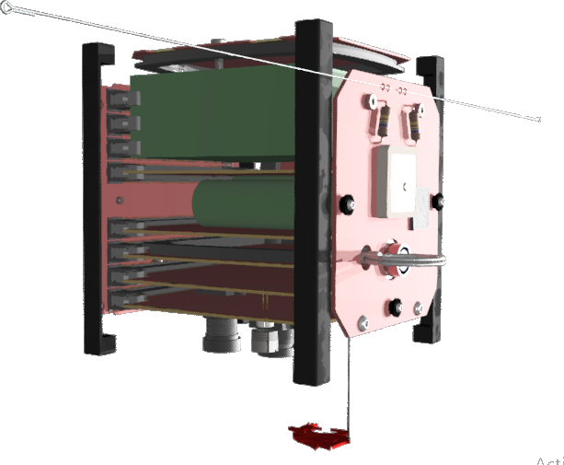

Solar Panel

Magnetorquer

Comms Antenna

GPS Antenna

Radiation Sensor

RBF Pin

Deployable Cougar Head

Figure 3: Preliminary 3D Rendering

## 5.1 Satellite Bus

The satellite bus consists of the mandatory subsystems for basic satellite operations. Future CougSats will share a similar, if not identical, bus. Below is a synopsis of their function, see each subsystem’s documentation for more details.

### 5.1.1 C&DH – Command and Data Handling

The C&DH subsystem performs the following responsibilities:

* Manages all forms of data on the satellite
* Carries out commands ordered by the ground
* Prepares data sent to and interprets data from the ground
* Collects and processes information about all subsystems and payloads
* Keeps and distributes the satellite’s time
* Autonomously monitors and responds to a wide range of onboard problems that might occur

The C&DH is comprised of the internal housekeeping unit (IHU) processor and a solid-state recorder. It also manages communication on the backplane; a subsystem talks though the IHU to another subsystem or the ground.

### 5.1.2 EPS – Electrical Power System

The EPS subsystem responsible for accumulating energy, regulating voltage, and distributing power. Energy from the sun is gathered through solar cells and stored in batteries. The EPS regulates voltage rails. Theses rails are distributed over the backplane on independent channels. The Power Management Integrated Circuit (PMIC) monitors and operates the EPS and is the only processor on CougSat-1 that cannot be turned off, except if the deployment switch is depressed.

### 5.1.3 ADCS – Attitude Determination and Control System

The ADCS handles positioning CougSat-1 in a desirable orientation. The primary source of attitude knowledge comes from an array of magnetometers, accelerometers, and gyroscopes. The ADCS controls attitude with the use of three magnetorquers. They generate a magnetic field that, through interaction with Earth’s magnetic field, induce a torque on CougSat-1.

The ADCS also performs a maneuver called “Roast the Chicken” whenever temperatures are out of nominal. During which, CougSat-1 begins to revolve in order to evenly distribute the time a side is exposed to the sun, and thus normalize the temperature throughout. The ADCS might also selectively heat or cool one section that is nearing dangerous levels.

### 5.1.4 Comms – Communication System

The Comms uses radio frequency signals to send and receive data to and from the ground. The frequencies are in the amateur radio (HAM) bands, or unlicensed bands (including the visible spectrum). The use of open frequencies allows CougSat-1 to communicate with operators around the world for distributed reception which increases the contact duration; a single station can see the satellite five to seven times a day for five to fifteen minutes each.

### 5.1.5 IFJR – In-Flight JTAG Reprogrammer

The IFJR connects via JTAG to each processor to program them whilst in orbit. This allows CIS to update software on CougSat-1 after it has been deployed and orbiting in LEO.

### 5.1.6 Mechanical Structure

The mechanical structure supports all of the components and boards in CougSat-1. The structure conforms to the CubeSat specifications, see their [document](http://www.cubesat.org/resources/) for details. During launch, it protects everything from the high acceleration and vibration. In orbit, it holds the subsystems rigidly together such that the ADCS can effectively orient CougSat-1 along with its subsystems.

## 5.2 Payload

The payload achieves the mission objectives. Each objective often has its own section in the payload. Below is a synopsis of each subsystem that fulfils a mission objective.

### 5.2.1 Validating the Satellite Bus

As the primary mission of CougSat-1 is to develop a satellite bus, the health statistics will be the most beneficial payload. On CougSat-1 there will be dozens of environmental sensors. Roughly $40$ temperature sensors will monitor each processor and integrated circuit, in addition to the solar panels, and structure. A radiation sensor will measure the amount of beta and gamma radiation impacting CougSat-1. The EPS measures the amount of power the sun is irradiating onto the solar panels. This data is regularly saved and sent to the ground.

### 5.2.2 Germination Experiment

The Astrobiology department of WSU is designing an experiment to test plant germination in microgravity. CougSat-1 will be testing an initial design of the experiment. The experiment consists of a pressurized greenhouse with seeds and growth nutrient. A camera, and various sensors monitor the seeds’ life status. A heater will keep the seeds at a proper temperature. The seeds will receive light through artificial illumination.

### 5.2.3 Earth Imaging

A high-resolution camera with a wide-angle lens will photograph earth. Possibly a second camera with a telephoto lens will take photos of small objects of interest such as Pullman.

# 6 Concept of Operations

CougSat-1’s operations throughout its mission are explained below. The order reads like a story and flows seamlessly to the next operation. The operations of CougSat-1 reflect the objectives of its mission, summarized below. See section 2 for more details on the mission objective.

1. Send satellite health telemetry
2. Perform payload operations

## 6.1 Before Deployment

Per the CubeSat specifications section 3.3: Electrical, CougSat-1 must be powered off until ejection from the P-POD. A remove before flight (RBF) pin is inserted to turn the satellite off during P-POD integration. Deployment switches on the end of the structural rails are also used to turn the satellite off whilst inside the P-POD. After the satellite is integrated into the P-POD, the RBF pin is removed, and the deployment switches keep the satellite off. To test the system and prepare for launch, the umbilical is connect which overrides the deployment switches and powers the satellite up. The umbilical also carries communication between a test computer and CougSat-1. A flight ready test is performed by each subsystem.

## 6.2 Immediately Following Deployment

Once the door to the P-POD opens, its spring ejects the CubeSats it contains, including CougSat-1. The deployment switches are released, and the EPS boots up. It runs a first boot sequence to ensure healthy conditions. Next, the EPS powers up the C&DH, which runs a similar initialization routine. The CubeSat specifications prevents deployable mechanisms from releasing until $30 minutes$ after ejection from the P-POD, and no RF transmission until $45 minutes$. The EPS starts a timer. The C&DH should take a photo of the launch vehicle immediately after its startup routine, given the launch provider allows it. The ADCS can immediately begin stabilizing the attitude. At the allowed time, likely $50 minutes$ for margin, the antenna will deploy, the Comms boots up, and normal operations begin.

## 6.3 First Few Days

The first few days, CougSat-1 is going to attempt to establish reliable communication with the ground. As the other satellite that are deployed along with CougSat-1 are fairly close together, reliably identifying which one is CougSat-1 might require several days in order to get the tracking parameters. NORAD tracks every satellite and generates the tracking parameters that will be used to control the ground station’s antenna. During this operation, CougSat-1 will be idle as a command from the ground is required to begin the germination experiment.

## 6.4 Germination Experiment

A command from the ground will trigger the start of the germination experiment. This operation is an extension of normal operations; thus, will follow the same modes as normal operations. At this time, the seeds will be introduced to the growth medium and water. At regular intervals per the experiment, data will be collected from its sensors. The numerical data will be compiled daily into a single packet to send down for analysis. The images can be downloaded immediately. The numerical data will be collected once an hour and the camera will take a photo daily.

## 6.5 Normal Operations

Here CougSat-1 will live most of its life. Normal operations are categorized in various modes and the current mode is dictated by health parameters, namely power level, and current objective, such as take a photo of Pullman. Throughout all of the modes, the Comms will regularly send out a beacon. The C&DH compiles a telemetry packet containing health parameters. The Comms transmits this packet along with a voice message. The message informs listeners about CougSat-1, encouraging them to visit our website, and concluding with an enthusiastic “Go Cougs!”. Likely, the packet will be modulated with data under voice, so the voice message and telemetry will be sent simultaneously. The beacon will send once every minute and should last roughly $8 seconds$ which allows the telemetry packet to be sent twice to improve odds of a successful receipt.

See figure 4 for a state diagram explaining the normal operations’ modes.

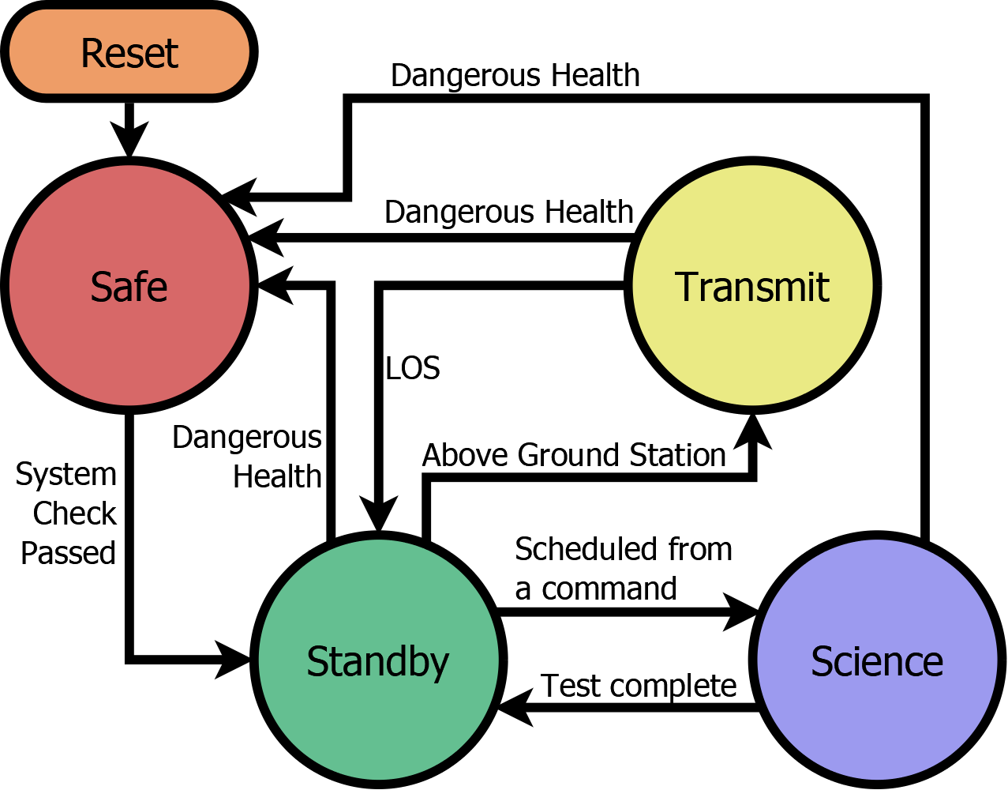

Figure 4: Normal Operation Modes

### 6.5.1 Mode 1: Safe

Safe mode is when all non-essential subsystems are shutdown to preserve the health of CougSat-1. The only subsystems that are on during this mode are the EPS, C&DH, and Comms. Safe mode is usually triggered when the power level is at a critical state but can be triggered by any health parameter that is out of nominal range. This mode is exited when all health parameters return to nominal values. The C&DH will regularly check the health parameters to decide when to return to the idle state. The Comms’ beacon is simplified to a CW signal Morsing “WSU” in order to save energy. The IHU might turn on the ADCS to change the attitude to improve the satellite’s health. An example maneuver is facing the hot side away from the sun (too hot) or facing the solar panels towards the sun (low power). After completion of the maneuver, the ADCS will be powered down.

### 6.5.2 Mode 2: System Maintenance & Standby

The idle mode is when Cougsat-1 is not performing science, all health parameters are within nominal values, and data transmission is not occurring, beacon still is transmitted during the idle mode. Here most of the time is spent. The ADCS is aligning the solar panels to face the sun. The IFJR may be turned on in this mode to perform a software update procedure, after which the satellite gets reset and enters safe mode.

### 6.5.3 Mode 3: Science

The science mode is when CougSat-1 is obtaining experimental data. This mode often lasts a few seconds as most of the experiments just require simple datalogging or a picture. The science mode may last longer if the ADCS is required to orient the craft to take a sensor reading such as to take a photo of Earth. Below is a list of activities that occur during the science mode:

* Germination Experiment – Reading sensor
* Germination Experiment – Imaging the seeds
* Imaging a subject of interest (such as Earth)
* Reading ionizing radiation sensor

Acquiring health data to analyze the effectiveness of the satellite bus occurs during all modes as the same data is used to trigger safe mode.

### 6.5.4 Mode 4: Transmit

When CougSat-1 is in range of a known ground station, data transmission phase is entered. The ADCS orients CougSat-1 to maximize the antenna gain to the ground. The C&DH and Comms begin constant bidirectional communication to send and receive data. After LOS timeout, this mode is complete.

## 6.6 Decommissioning

As stated in section 1.2, the expected lifespan of CougSat-1 is a year. Provided it is still functional, it will continue to operate past this estimation. Once the satellite either breaks, refuses to communicate, or vaporizes whilst re-entering Earth’s atmosphere, the mission has ended. All of the data collected will be archived and a memorial service will be held to honor the achievements of CougSat-1.

1. K&K Associates (2008). [Earth’s Thermal Environment](http://www.tak2000.com/data/planets/earth.htm). *Thermal Environments JPL D-8160*.
2. Illinois Tiny Satellite Initiative. [Thermal Control](http://cubesat.ece.illinois.edu/Structure.html). *CubeSat @ UofI*.
3. NOAA (2015). [The World Magnetic Model](https://www.ngdc.noaa.gov/geomag/WMM/). *NOAA Geomagnetic Data & Information.*